# 3 Things are needed to create a DBA request now.

RITM – this is for each plan MI

CHG – one to many

CTASK

Without all 3 of these, DBA will not work on your request. Here is how to create each of these

# Creating a Database Support Request (RITM)

Link :

<https://aetnaprod1.service-now.com/sp_home?id=sc_cat_item&sys_id=2df82e6fdbc9a550cb53efe813961912&sysparm_category=e5257a306f4fd10007a5f00dba3ee46a>

## Notes on Fields :

Technical Offering – Choose the item that best describes what you need done.

Technical Offering Details -- **First text in Technical Offering Details should be DBA Medicaid Business Unit.** Include ALL the specifics for what you need done. Full Server names, script details, etc. Lack of information will delay your request.

Instance Name – MSSQLServer@Actual Server name. Aliases cannot be used here.  If you don’t know the actual server name connect to the server in SSMS and run “select @@SERVERNAME”.

Support Group – DBA SQL SERVER until our Medicaid group is added.

Supported by Individual – Leave this blank.

**Checkbox for Open a Draft Service Now Normal Change to create the required Change Ticket for Production Changes**. This will create the CHG ticket – more details on the steps for this below

Attachments – Add scripts for the task. T**his will no longer work in the future, you will need to use a Github repository link**

Screenshots Below

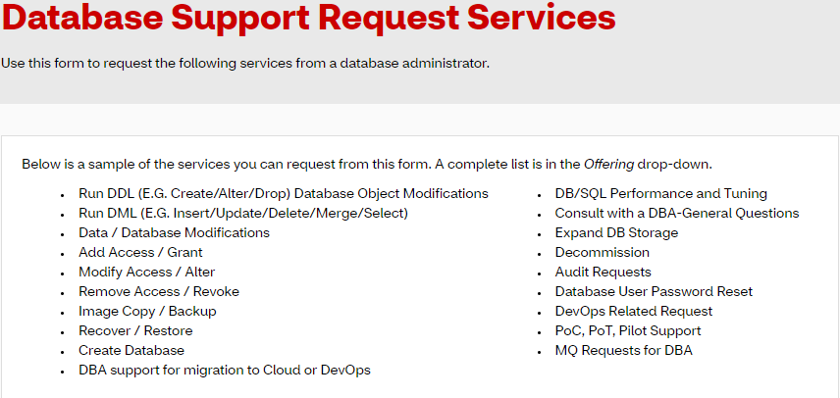

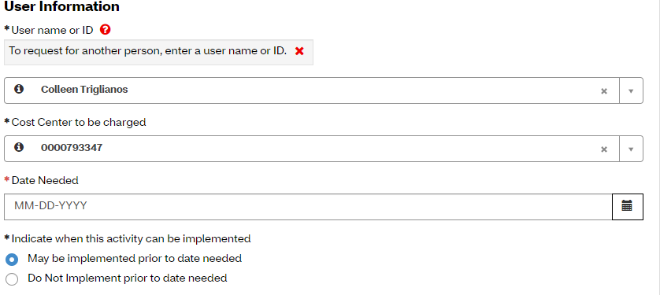

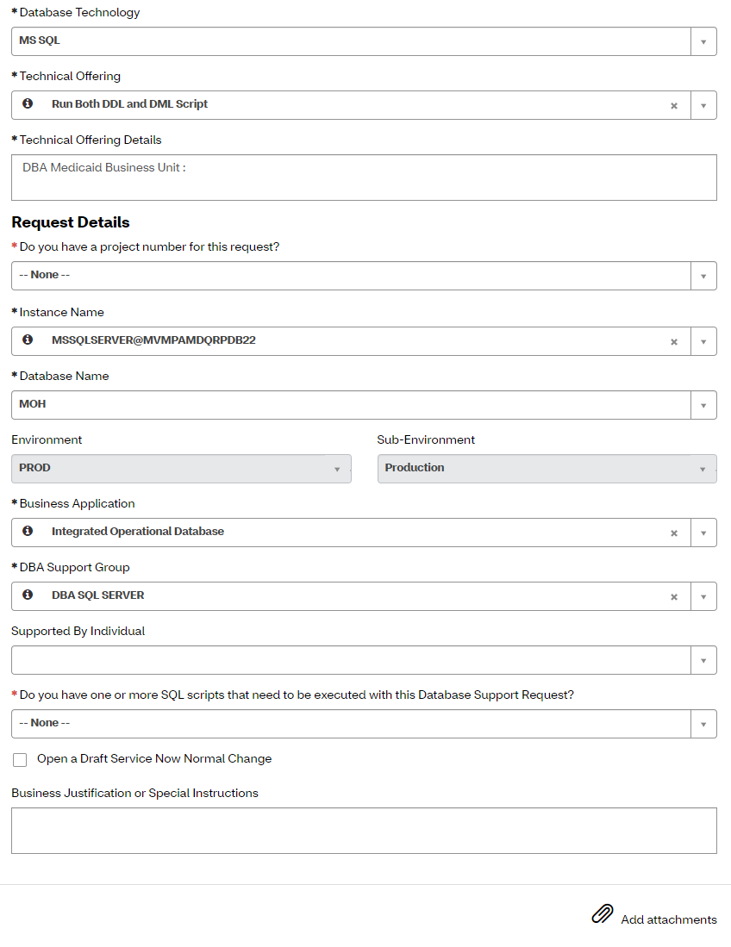

Creating a Database Support Change Request(CHG)

After you create the RITM you need a CHG request that is linked to it. If you already checked the Open a draft service box you will have the CHG request created and linked already. If you forgot to check the box, you can follow these steps to create and link a new CHG request:

Creating and linking a new CHG request(Only do this part if you didn’t check the box):

1. Follow this link to create the change:

<https://aetnaprod1.service-now.com/now/nav/ui/classic/params/target/wizard_view.do%3Fsysparm_wizardAction%3Dsysverb_new%26sysparm_stack%3Dchange_request_list.do%26sysparm_parent%3D8db4a378c611227401b96457a060e0f4%26sys_target%3Dchange_request>

or

<https://aetnaprod1.service-now.com/navpage.do>

or

<https://itsm.cvs.com/now/nav/ui/classic/params/target/incident_list.do%3Fsysparm_userpref_module%3Df614eea513f59fc430cbfc62e144b09e%26sysparm_query%3Dassigned_toDYNAMIC90d1921e5f510100a9ad2572f2b477fe%255Eactive%253Dtrue%255EEQ>

1. Select the first option: *Create Normal Change: Normal Changes are a general purpose change type that requires one or more approvals.*
2. Fill out all of the information and press submit(Details on how to do this will be in the next step)
3. At the bottom of the CHG request navigate to Load Related Lists and press it

1. Select the tab Requested Items and press Edit/Add



1. On the left side enter your RITM and will pop up. Then select it and press the right arrow to move it to the right side. This will link it to the CHG.

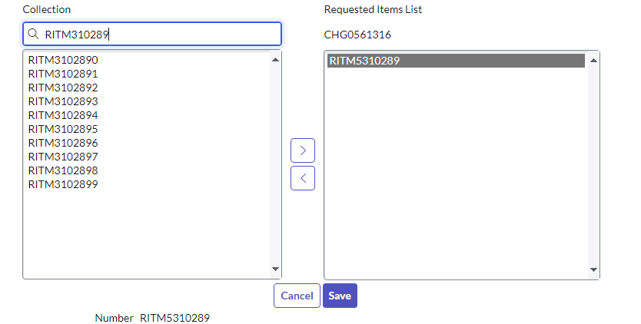

1. After this press save. This RITM is now linked to the change. You can do this to add multiple RITM to the CHG request.

Filling out the CHG request:

Fill out the CHG request with the information for your request. The CHG is something that you assign to yourself. Make the Environment Production and the assignment group Medicaid production support. You should be able to select your name after that.

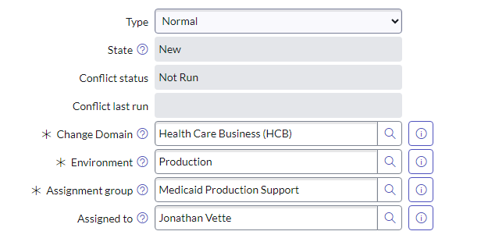

After you enter this information, you need to fill out the planning and schedule tabs below. Make sure that you leave a large window of time for the Planned start date and end date to give DBAs time, they will not work on a request that is past the end date. After you are done this step and filled out all the required information you can submit the CHG request. This will save your progress and let you make more changes to your request.

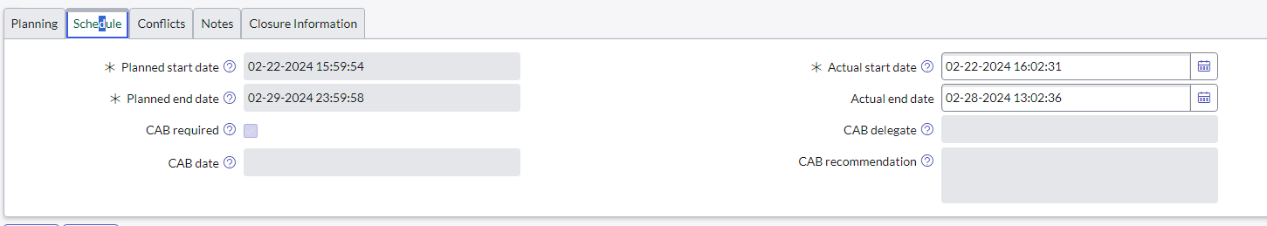

Creating a CTASK under the CHG request:

We need to create a CTASK (Change task) under the CHG for the DBA request. To do this go to the bottom of the CHG request, and press load related lists. The first tab is called change Tasks. Once you are at this tab, press the new button to make a new CTASK.

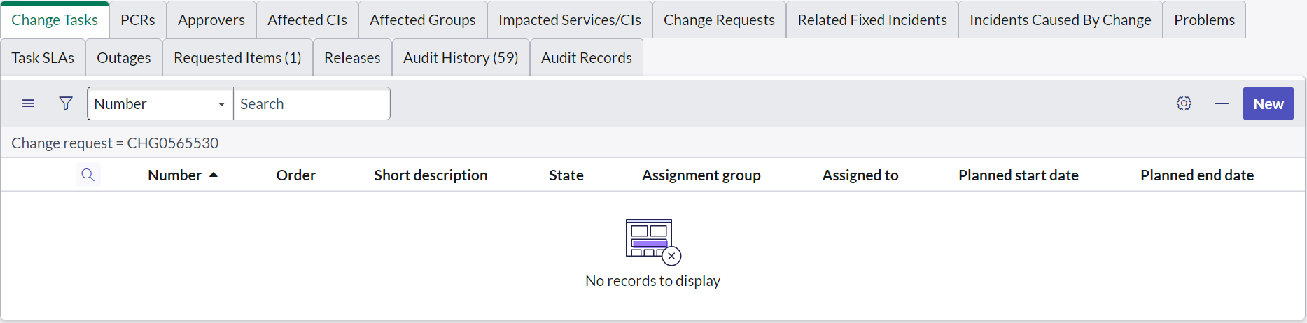

Once you press new, you can fill out the CTASK. This is like the old DBA requests we had in Remedy. Make the assignment group DBA Medicaid Business Unit and assign it to a DBA. Add your RITM number in the description. Make sure the planned start date and end date are in the same range as your CHG request. When you are done you can press the submit button.

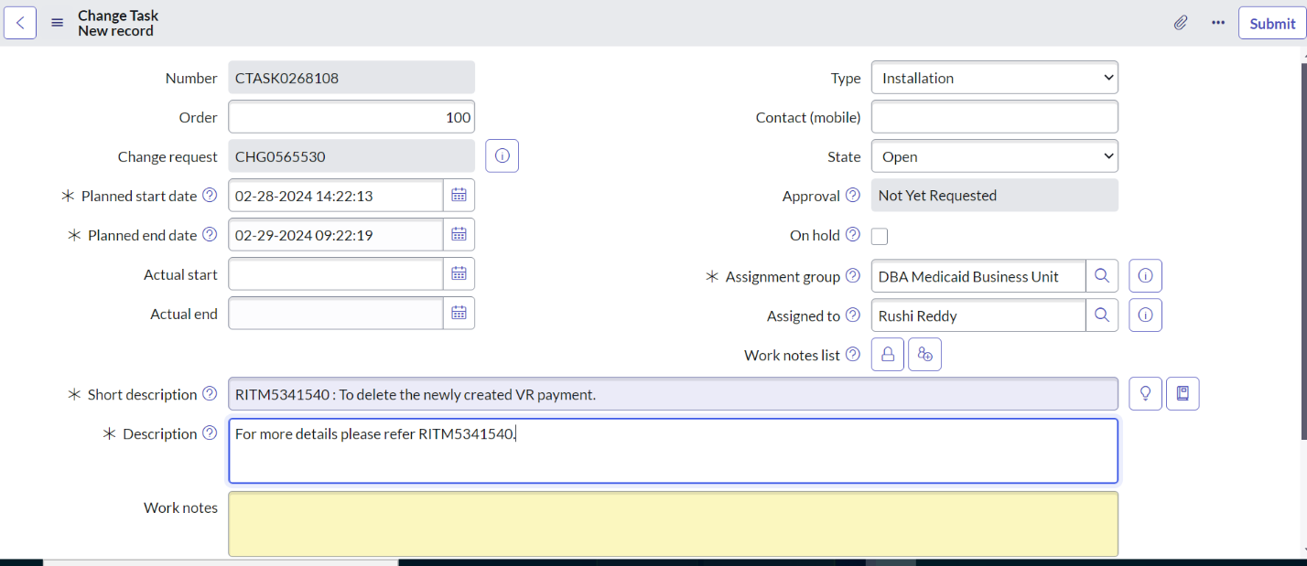

Attach IVB:

An IVB is an excel sheet that tells DBA exactly what to do. A sample IVB was provided to us. Attach it to the CHG request at the top

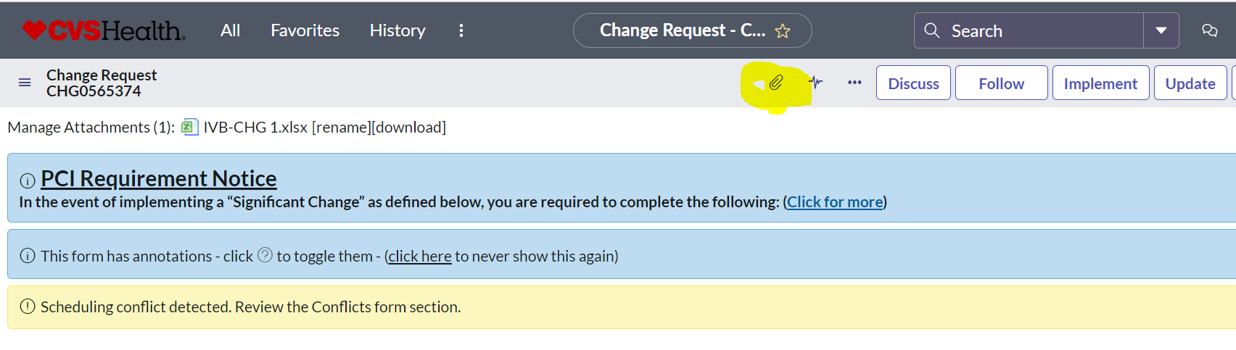

Add and Perform CIs (Conflicts):

This step is required to make sure there are no server conflicts. Go to the related lists at the bottom of the CHG and find the Affected CIS tab.

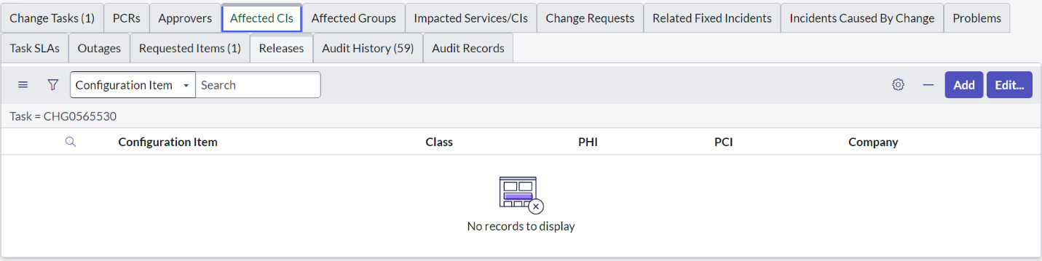

From here, press the Add button and then search for the actual server name (The one provided in the RITM you made earlier). After you selected it, press the add selected button on top.

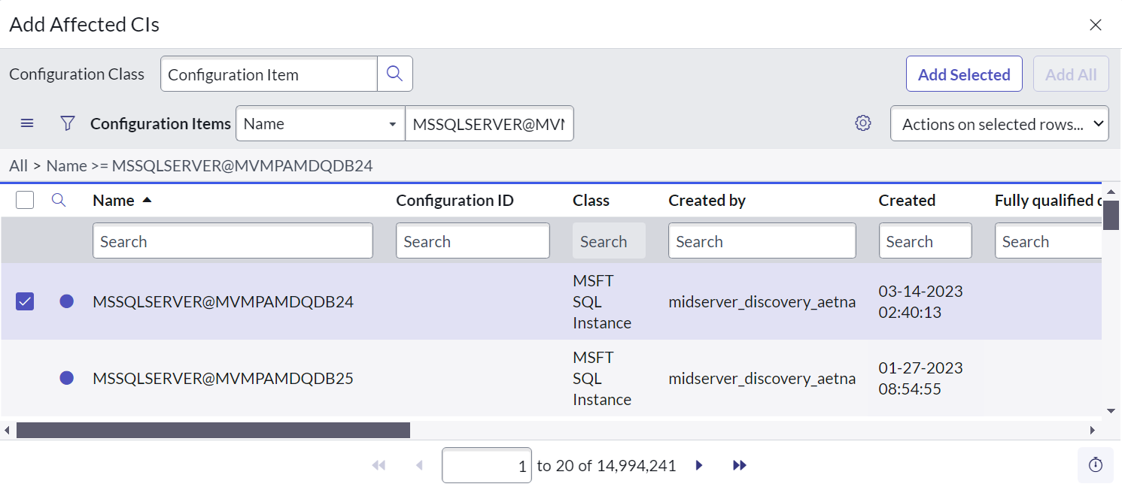

Once the server is added you can now run the conflict check. At the top of your CHG request there should be a button called check conflicts. Pressing it will complete the conflicts step.



Do Risk Assessment:

To do risk assessment locate the related links section near the bottom of your CHG request. Click on the Risk assessment link and fill out the information. It will then calculate how much risk there is to your change. Ideally, your request should be low risk.



Request approval(First Stage Approval):

Once all of these steps are complete, you can now request your CHG to be approved. There will be a new button on the top of the CHG request to submit it for approval

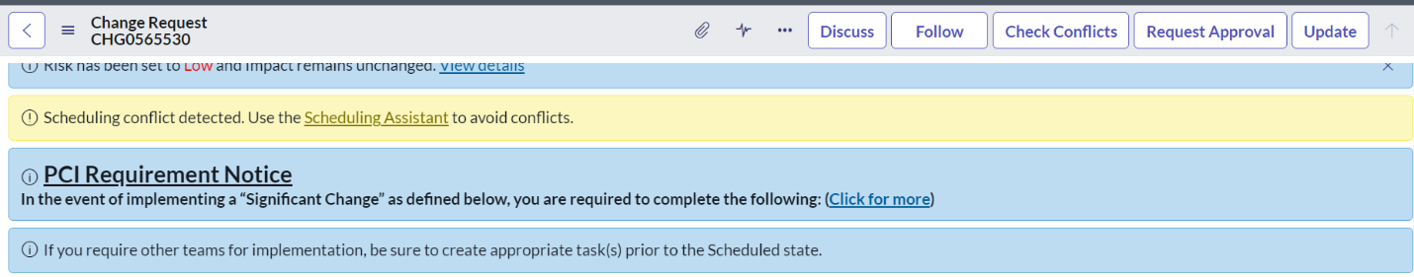

Once you request approval, the CHG should move from the new stage to the assess stage.

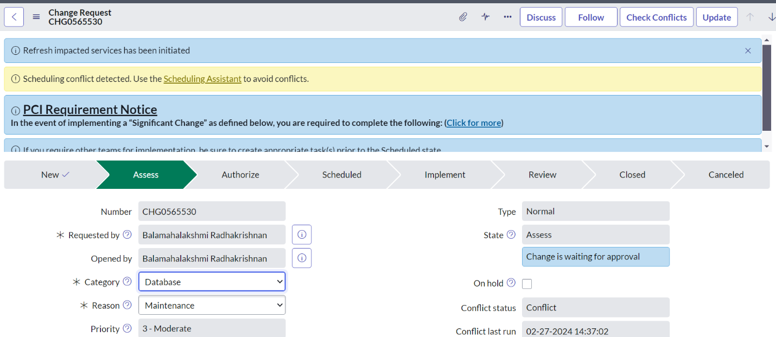

If you go to the related lists section at the bottom of the CHG and select the approvers tab, you should see the approvers needed for your CHG approval. You can email them or IM them and ask for approval

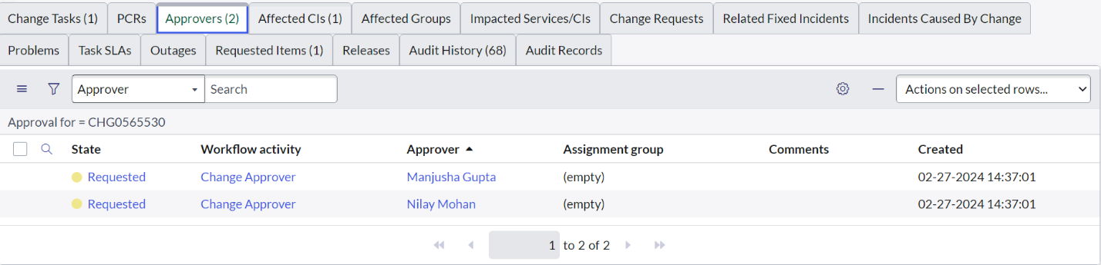

Authorize(Second Stage Approval):

After your CHG gets approved, it will move to the Authorize step. You will need to get approvals from someone else. The information on who to reach out to will also be in the approvers tab.

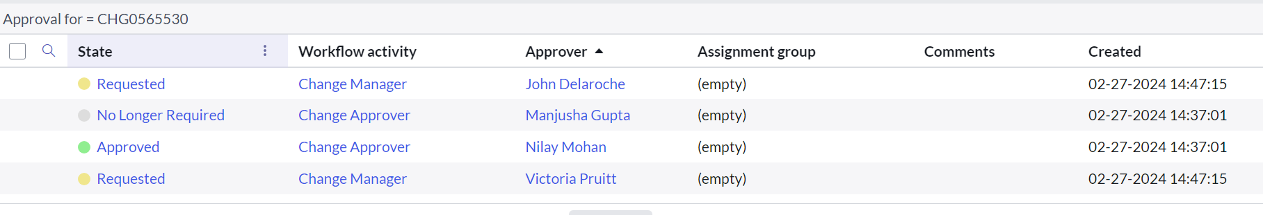

Move to Implement Stage:

Once you get approval, you need to move the CHG to the implement stage. There will be a button up top to move it here. (Don’t have a screenshot for this yet.)

Common Issues:

If you have an error message that comes up, let me know so I can add it to the documentation.

Planned start date cannot be before Change created date.

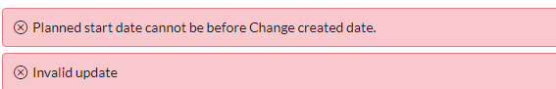

If you are getting this error message, you need to change the Planned start date to a time in the future. It will not accept a ticket where the start time has already passed.

TODO:

Githib repo step